# Lab Manual 5

**Configuration of Virtual Local Area Network (VLAN)**

**CLO 2**

Create the following Network topolgy:

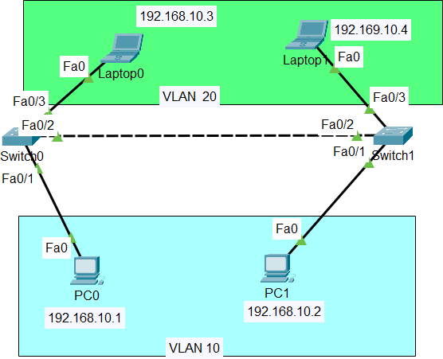

**Create 2 VLANs on the switch:** VLAN 10 and VLAN 20. You can give them custom names.

Switch#config terminal Switch(config)#vlan 10

Switch(config-vlan)#name SALES Switch(config-vlan)#vlan 20 Switch(config-vlan)#name IT

And just before you configure, have in mind that switch ports could be either access or trunk.

* An *access port* is assigned to a single VLAN . These ports are configured for switch ports that connect to devices with a normal network card, for example a PC in a network.
* A *trunk port* on the other hand is a port that can be connected to another switch or router. This port can carry traffic of multiple VLANs.

So in our case, we’ll configure switch interfaces fa

0/1 as access ports to connect to our PCs. Here, interfaces fa 0/1 assigned to **VLAN 10** while interfaces fa 0/3 are assigned

to **VLAN 20.**

Switch *Interface* fa0/2 will be configured as trunk port, as it will be used to carry traffic between the two VLANs via the router.

Perform the underlying steps for switch 0 and switch 1 separately:

Switch>enable Switch#config terminal Switch(config)#int fa0/1

Switch(config-if)#switchport mode access

Switch(config-if)#switchport access vlan 10

Switch(config-if)#int fa0/3

Switch(config-if)#switchport mode access Switch(config-if)#switchport access vlan 10 Switch(config)#int fa 0/3

Switch(config-if)#switchport mode trunk

**4 .** Assign static IP addresses to the four PCs which are located in the separate VLANs. PC0 and PC1 fall in VLAN 10 while laptop0 and laptop fall in VLAN 20. At this point let’s try to test

connectivity **within** VLANs and **between** VLANs

## Conclusion: